JS Advanced: Exam 19 December 2016

Problems for exam preparation for the “JavaScript Advanced” course @ SoftUni. Submit your solutions in the SoftUni judge system at https://judge.softuni.bg/Contests/375/.

Problem 2. Add Left / Add Right / Clear (Unit Testing)

You are given the following JavaScript code:
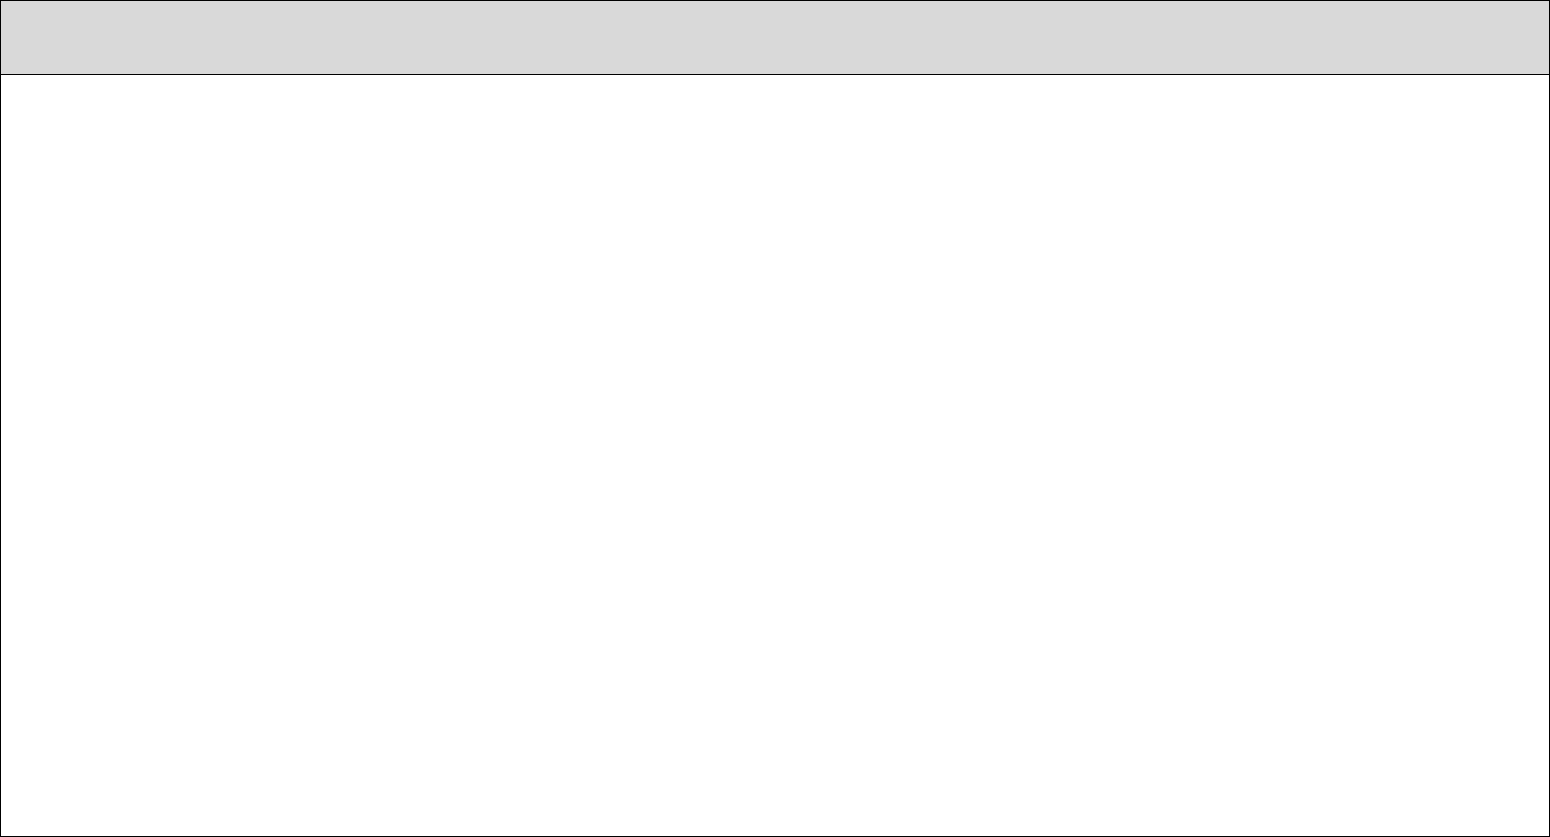
list-add-left-right-clear.js

function makeList() { let data = []; return {

addLeft: function(item) { data.unshift(item);
},

addRight: function(item) { data.push(item);
},

clear: function() { data = [];
},

toString: function() { return data.join(", ");

}
};

}

module.exports = makeList;

Functionality

The above code creates a list data structure that holds items (of any type). It supports the following operations:

- addLeft(item) – adds item at the beginning of the list.

- addRight(item) – adds item at the end of the list.

- clear() – removes all elements in the list.

- toString() – returns the string representations of the list items, separated by “, “.

Examples

This is an example how this code is intended to be used:

Sample code usage

let list = makeList(); console.log(`list = [${list}]`); list.addRight(1); list.addRight("two"); list.addLeft(0); console.log(`list = [${list}]`); list.clear(); list.addLeft("beer");


Corresponding output

list = []

list = [0, 1, two] list = [3.14, beer]

© Software University Foundation (softuni.org). This work is licensed under the CC-BY-NC-SA license. Follow us:  Page 1 of 2

list.addLeft(3.14); console.log(`list = [${list}]`);

Your Task

Using Mocha and Chai write JS unit tests to test the entire functionality of the list object. Your code will only be provided the list function, how you test the list is entirely up to you - whether you create a new list before each test or share the same list between tests.

You should have at least 6 test cases, make sure you cover all edge cases. You may use the following code as a template:

describe("TODO …", function() { let myList = {};

beforeEach(function () { myList = makeList();

});

it("TODO …", function() {
// TODO: …
});

// TODO: …
});

Submission

Submit only your tests as “JavaScript code (Unit Tests with Sinon and Mocha)”.

© Software University Foundation (softuni.org). This work is licensed under the CC-BY-NC-SA license. Follow us: Page 2 of 2

